The Punjab School (DRC)
Play Group Syllabus Outline
Mid Term 2020-21
Math | - Oral:  - Strokes: (Horizontal, Vertical, Diagonal, Semi Circle, and Circle)  - Counting 0-10  - Recognition 0-10  - Written:  - Tracing 0-10  - Count and colour  - Shapes: Circle and Square
English | 1. Oral:  - Reading and Recognition A-L  - Phonetics A-L  - Vocabulary A-L  - Rhymes  2. Written:  - Tracing A-L  - Find and encircle/colour the same letter A-L
Urdu | 1۔پڑھائی۔(اتاژ)  پڑھائی و پہچان، ذخیرہ الفاظ، نظمیں  2۔ لکھیے۔(اتاژ)
* On account of unexpected holidays, syllabus may be revised later.

The Punjab School (DRC)
English | - Do practice of stroke vertical, horizontal, diagonal  - Worksheet no 1,2,3  - Do Practice letter “I” and “L”  - Worksheet no 4,5
Urdu | "ا۔آ" اور "ب" کے خاندان کی کی مشق کریں۔
Maths | - Do practice number“1,4,7”  - Worksheet no 1,2,3
Conversation  (oral) | Q1: what is your name?  Ans: My name is……..
G.K  (oral) | Q1: Name and identify parts of body.  Ans: Eye, Nose, Hair, Ear, Hand, Leg
Islamiat (oral) | Q1: Who are we?  Ans: We are Muslims  Q2: Who made us?  Ans: Allah made us.
Play Group Vacation Engaging Task

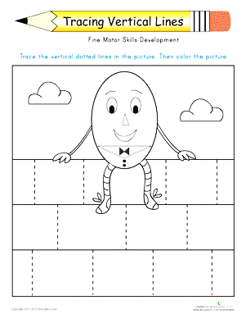
The Punjab School (DRC)

Worksheet :1
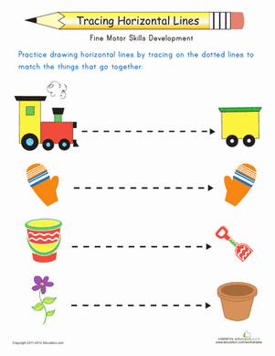
Worksheet:2
The Punjab School (DRC)

Worksheet: 3
The Punjab School (DRC)

Tracing Diagonal Stroke

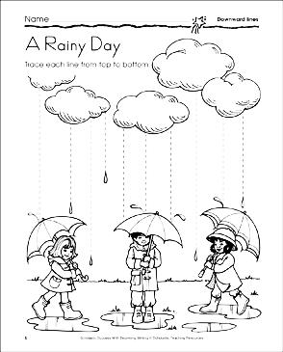
The Punjab School (DRC)

Worksheet:4

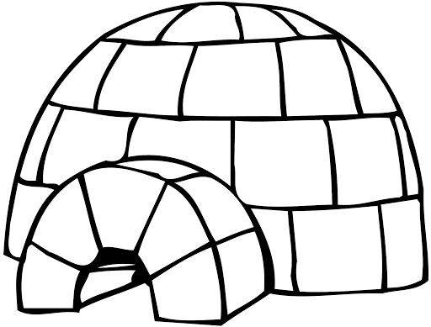

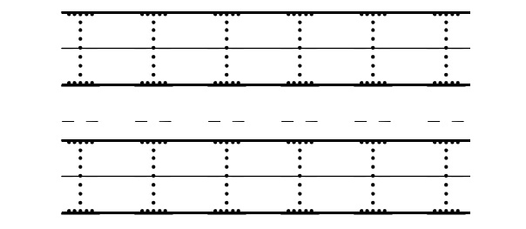

The Punjab School (DRC)

Worksheet:5

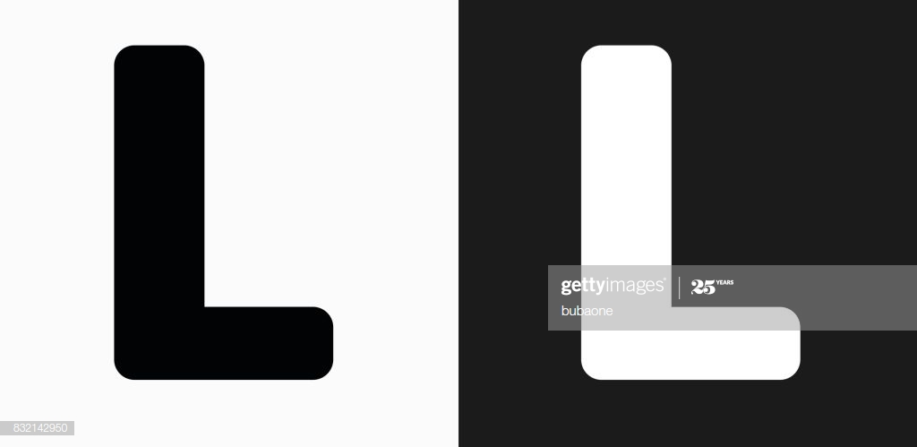
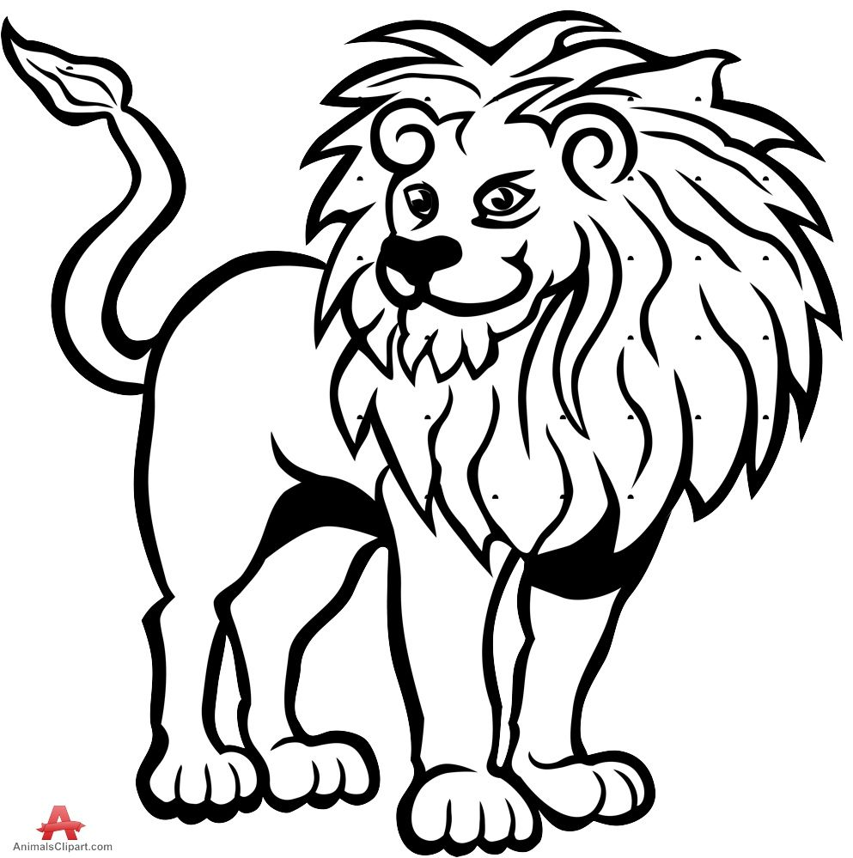

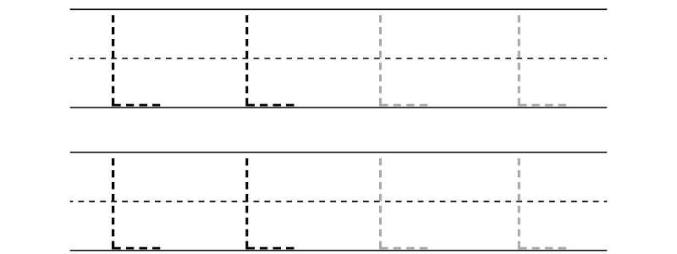

The Punjab School (DRC)

Worksheet:1



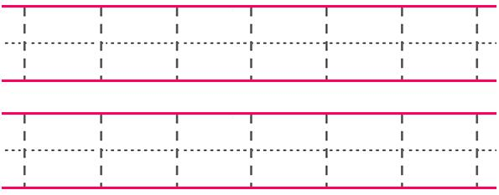

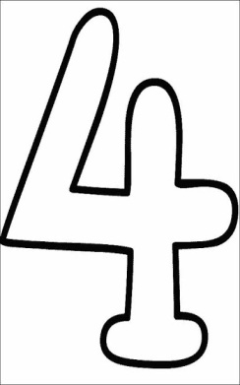
The Punjab School (DRC)

Worksheet:2
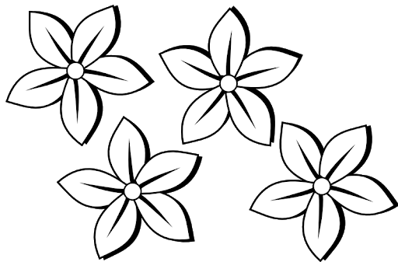

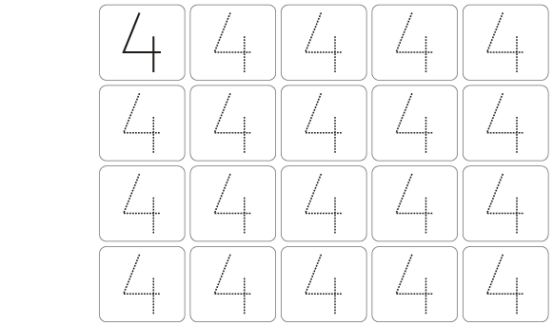

The Punjab School (DRC)

Worksheet:3
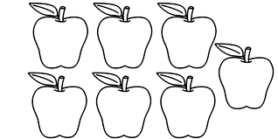
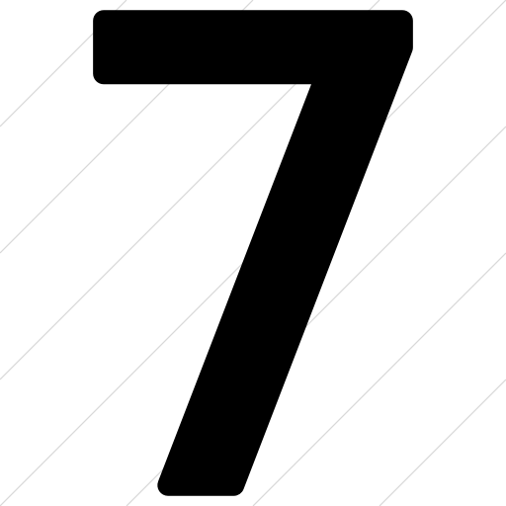

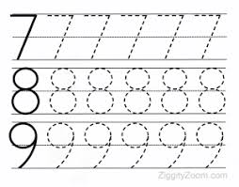

Worksheet:1
The Punjab School (DRC)

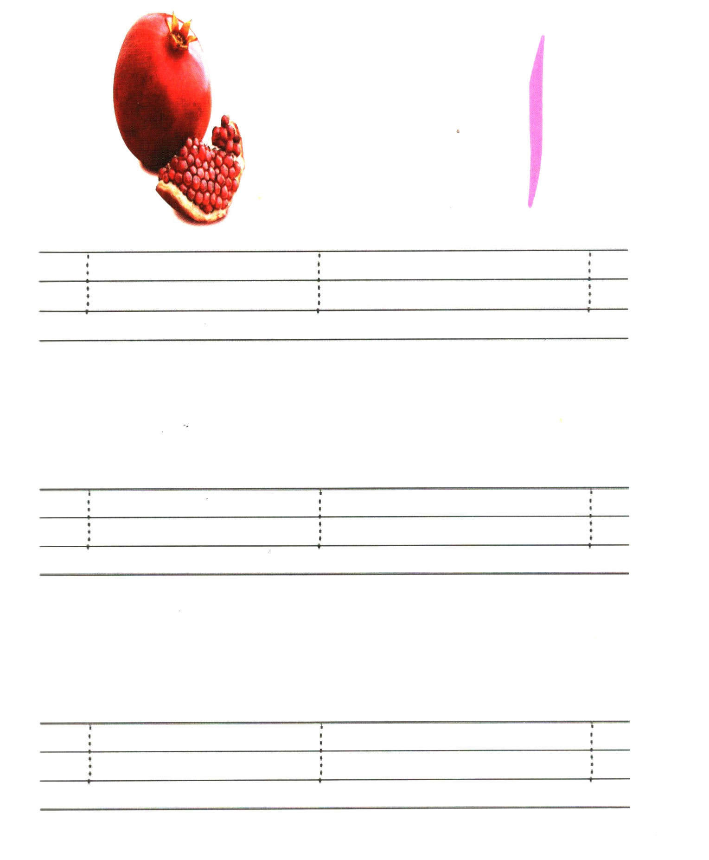
The Punjab School (DRC)

Worksheet:2
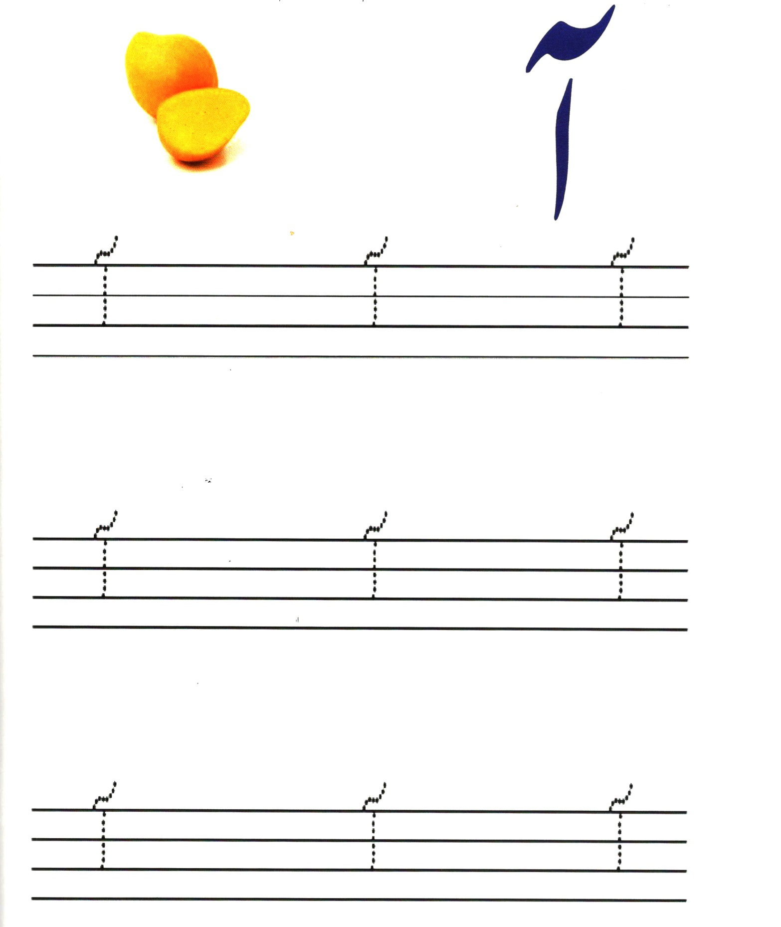
The Punjab School (DRC)

Worksheet:3
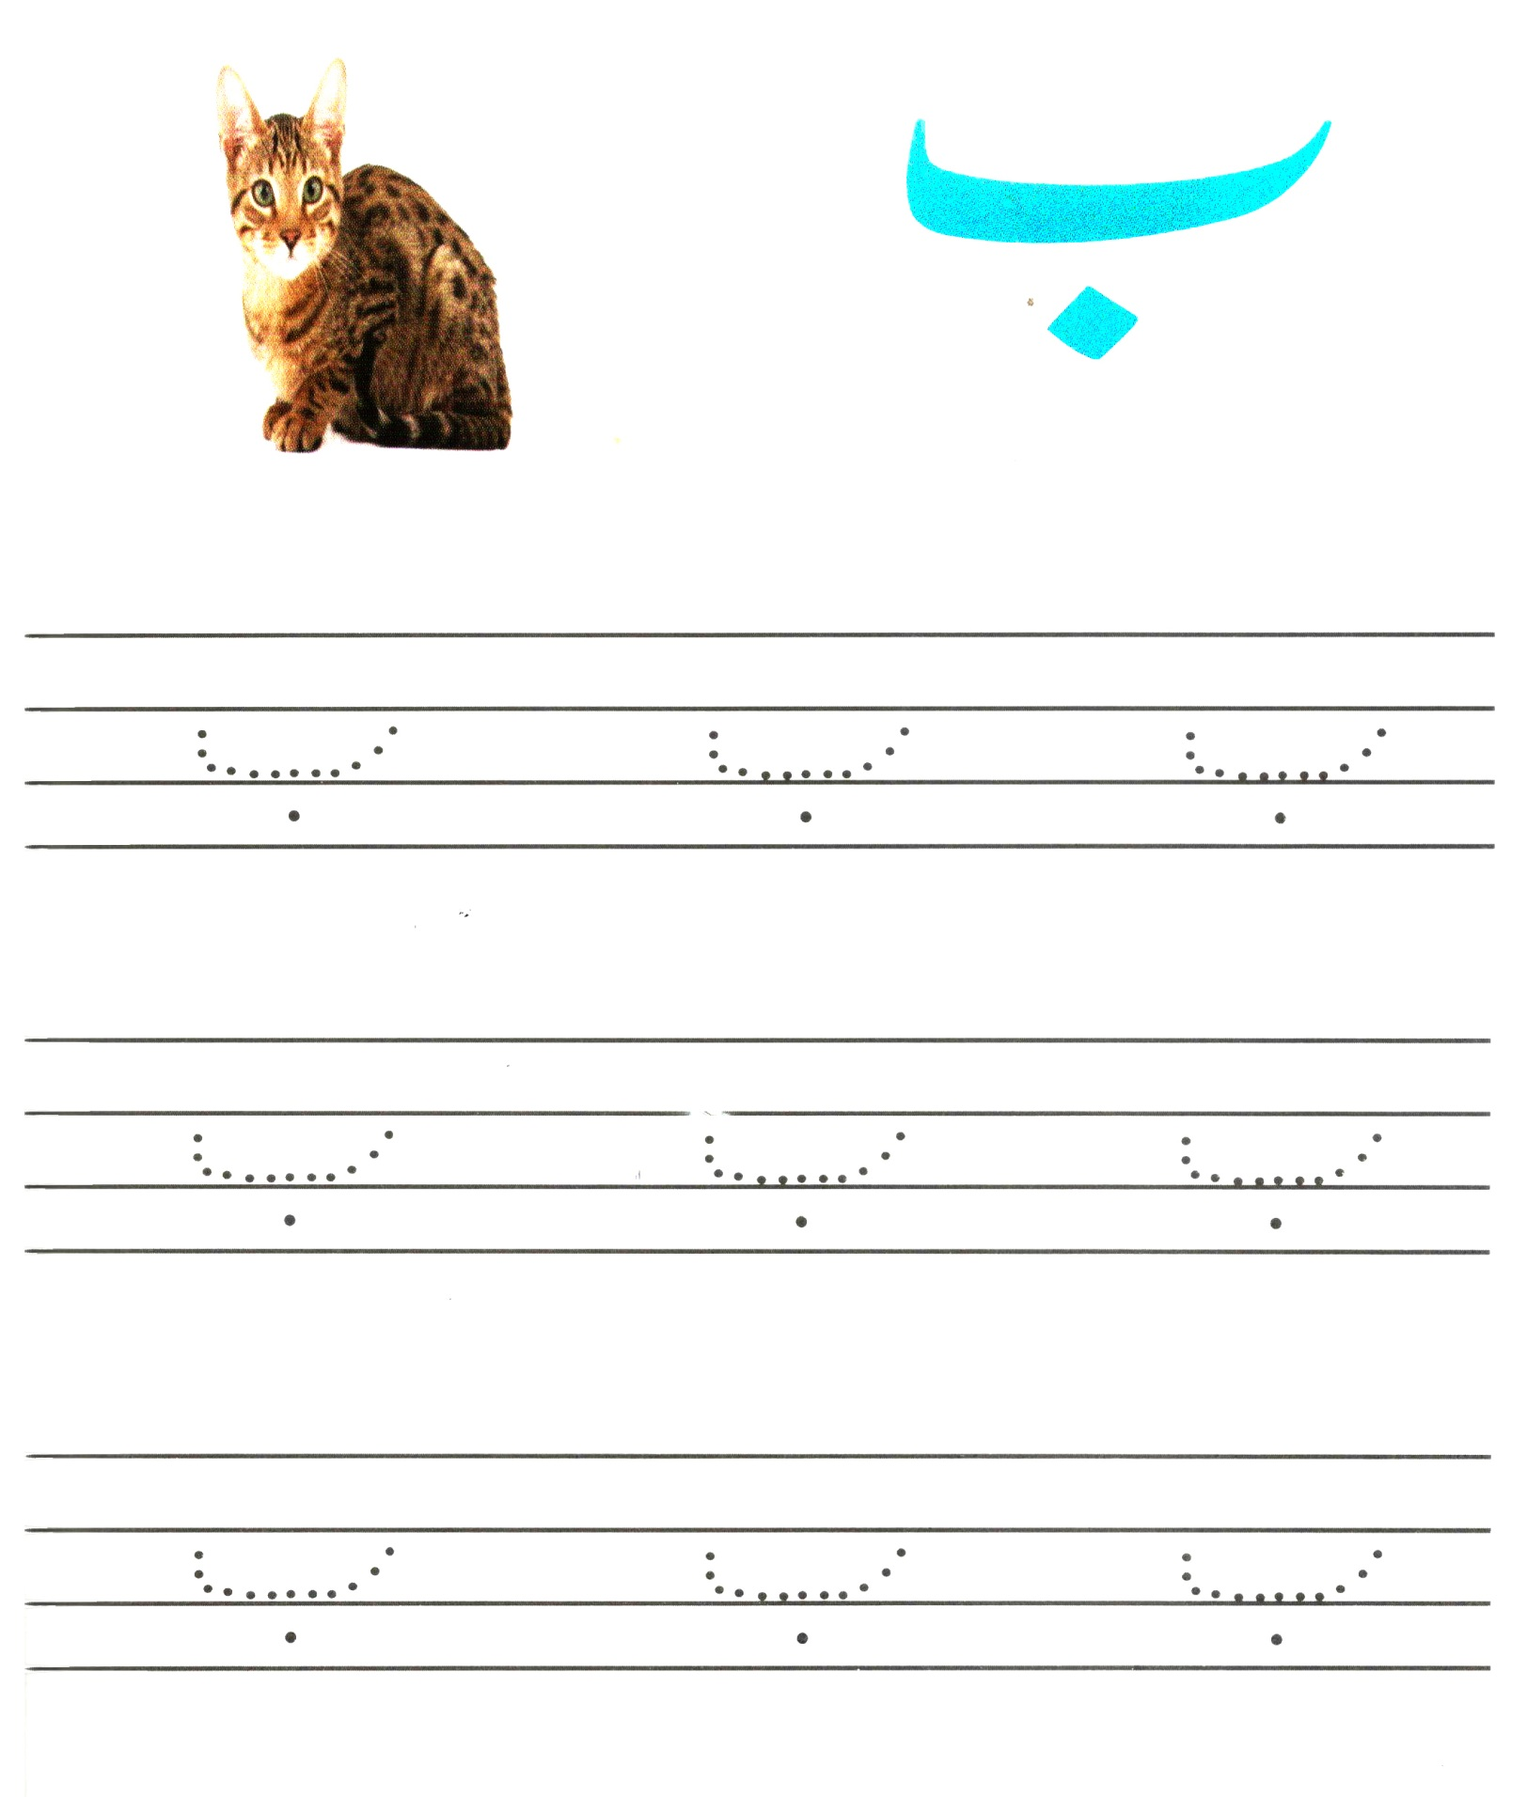
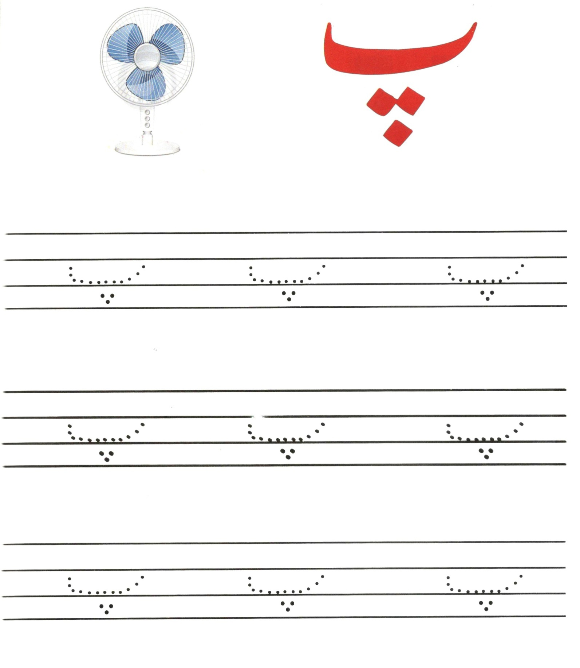
Worksheet:4
The Punjab School (DRC)

The Punjab School (DRC)

Worksheet:5
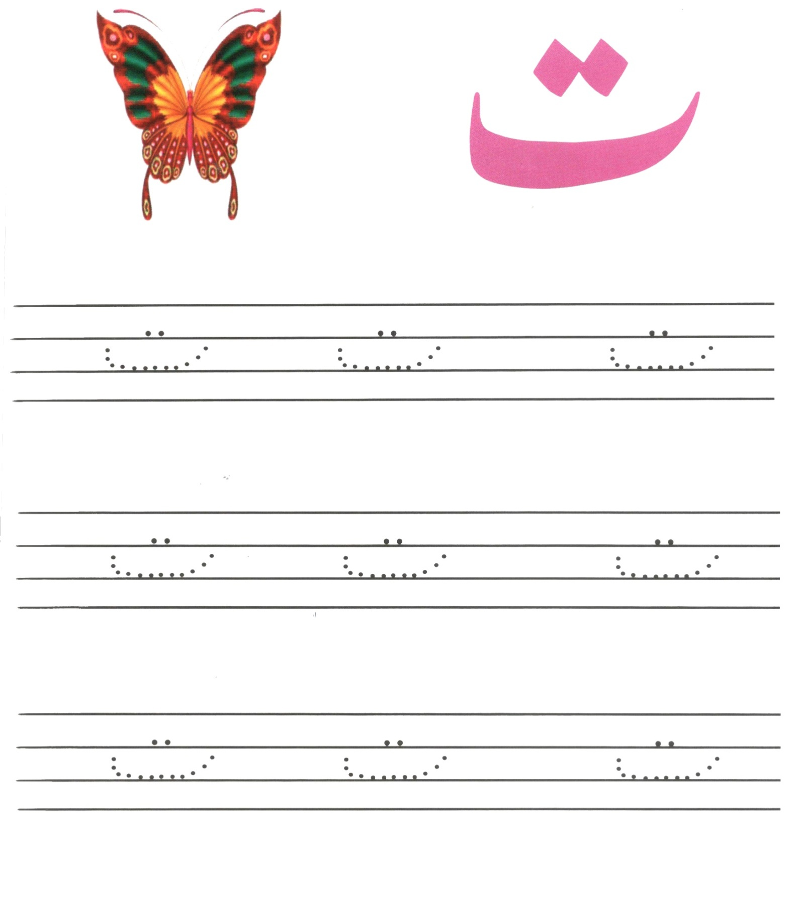
Worksheet:6
The Punjab School (DRC)

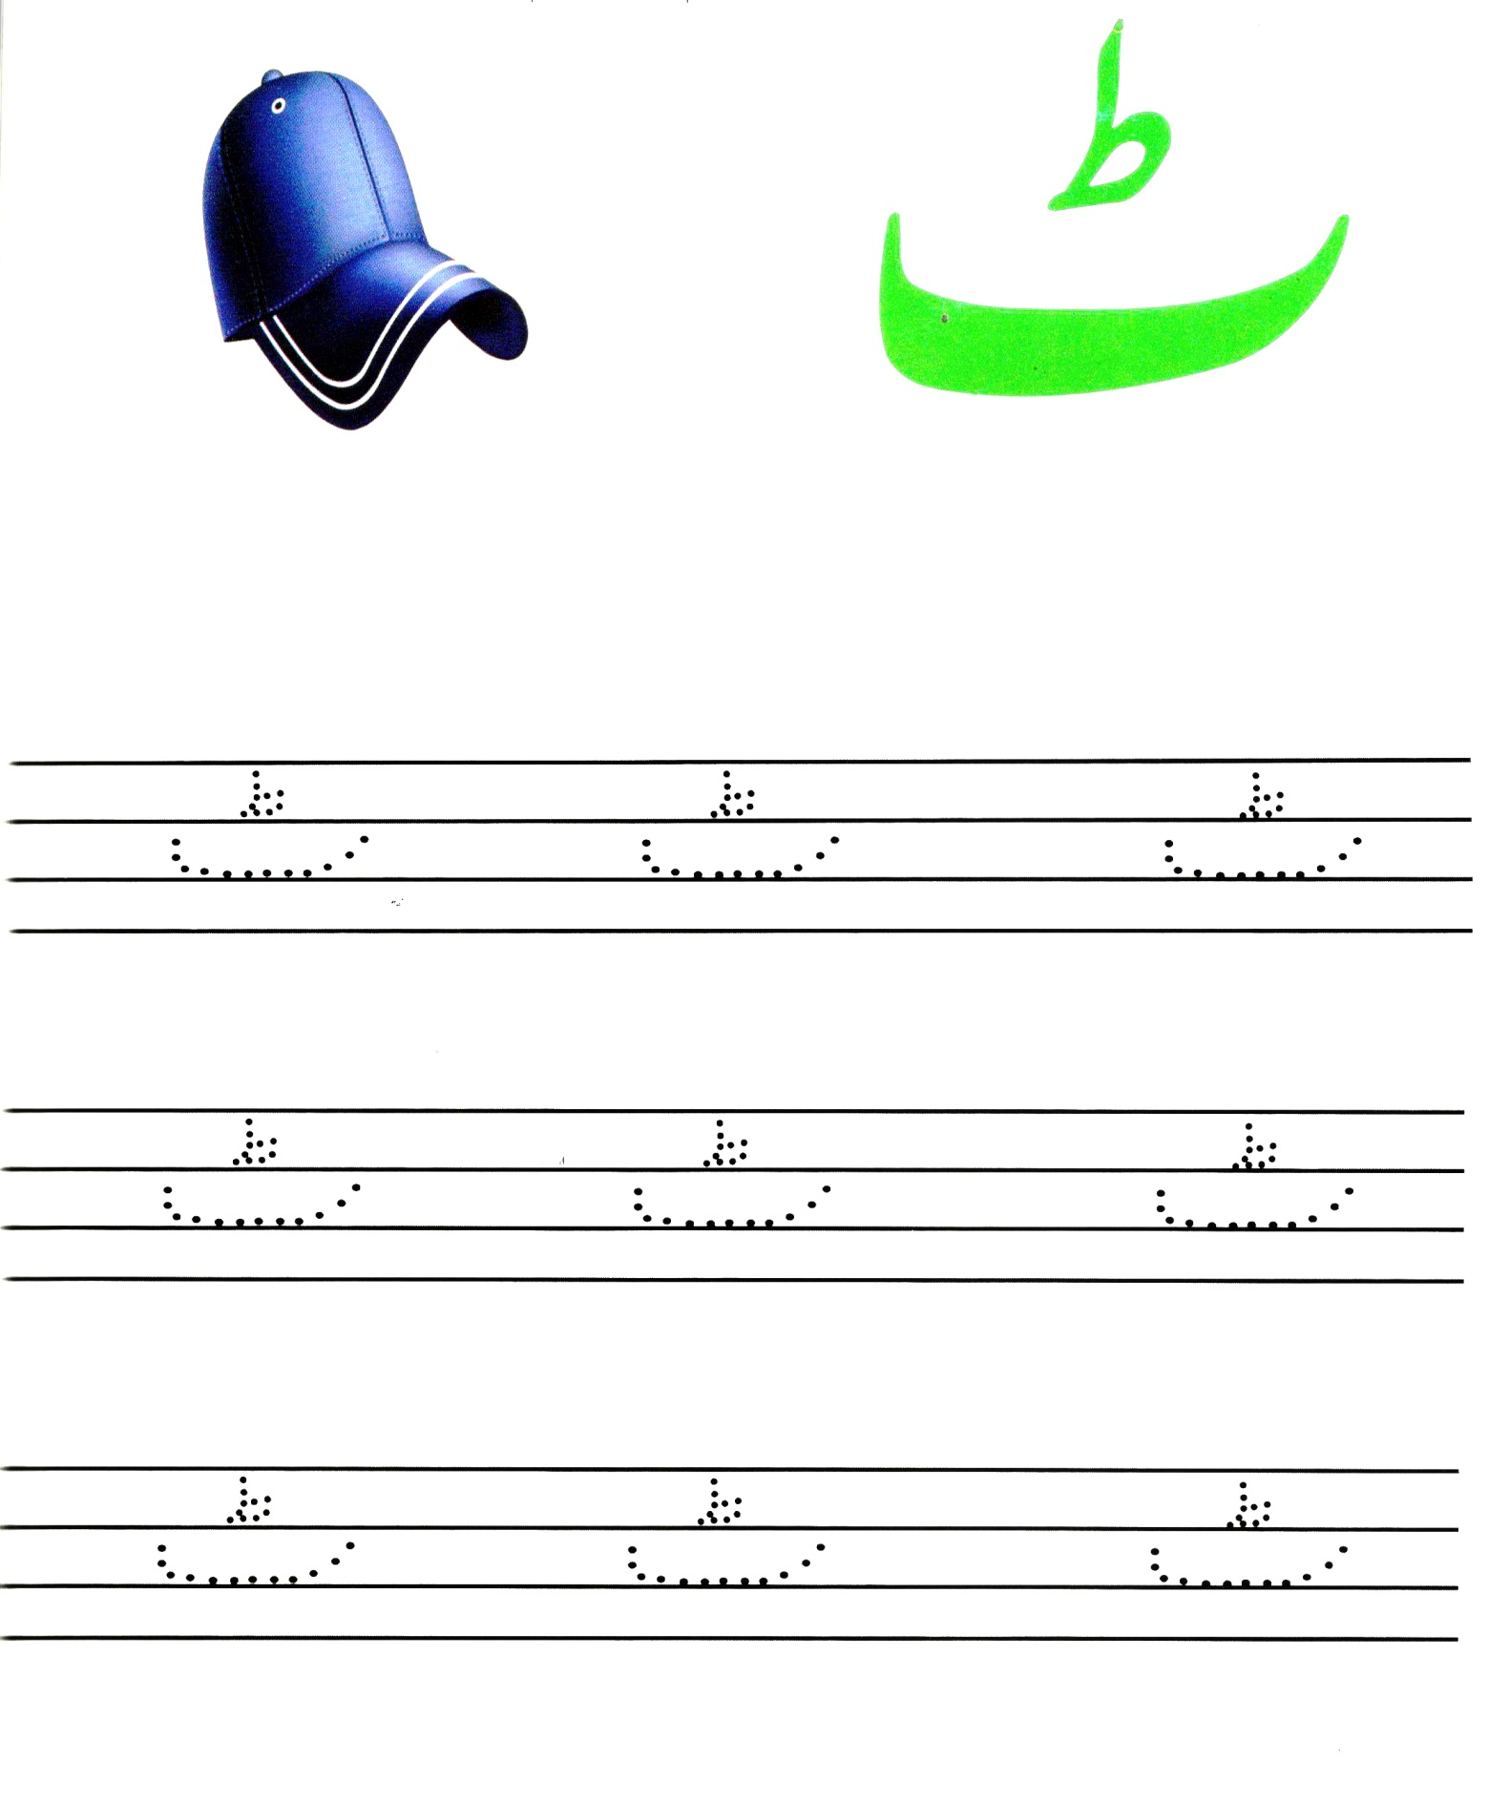
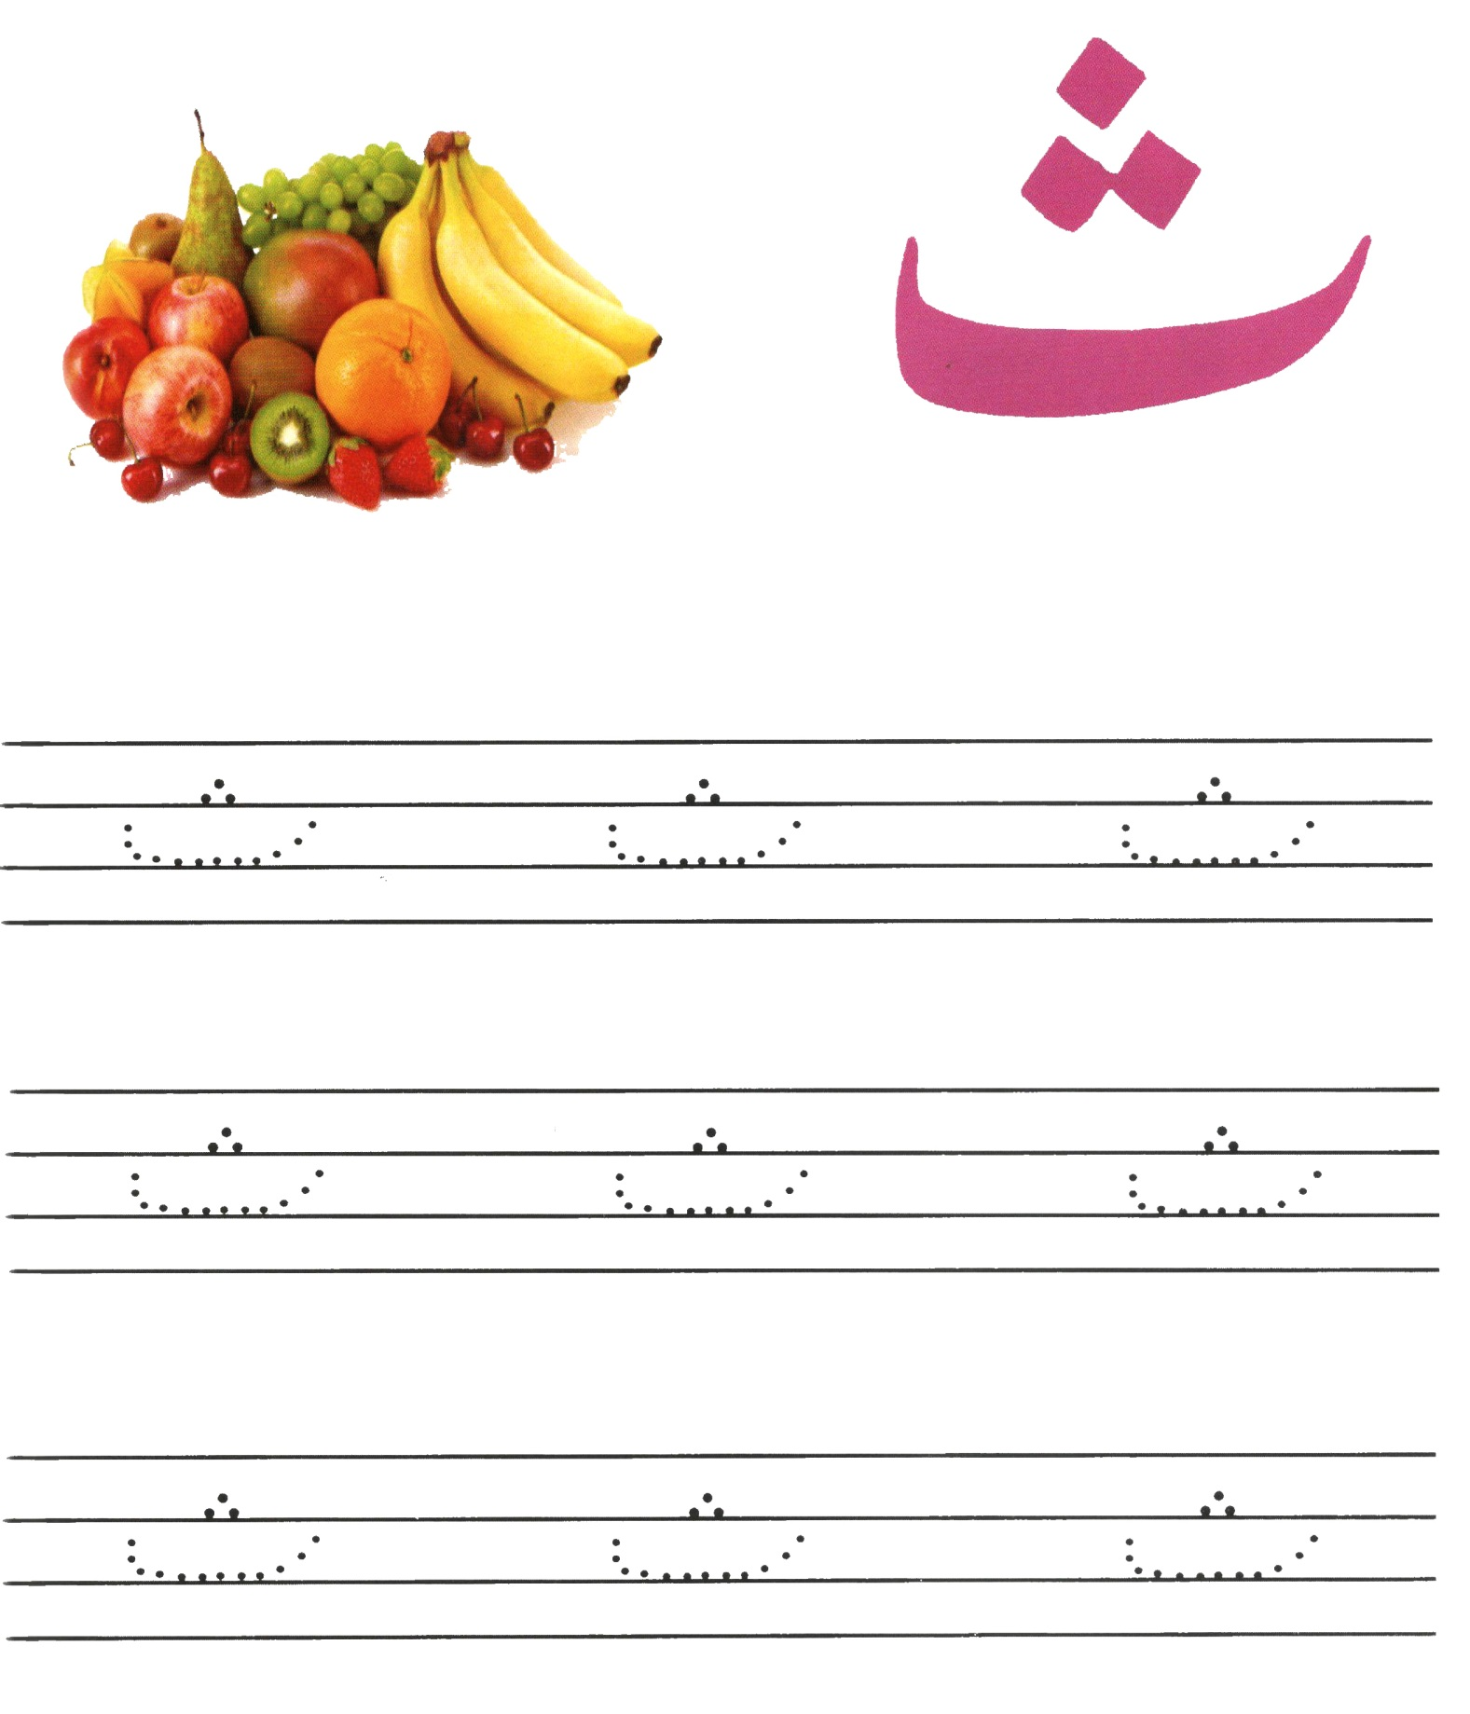
The Punjab School (DRC)

Worksheet:7

